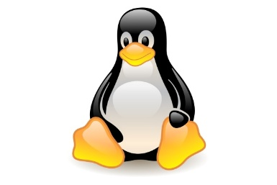
Linux

- INTRODUCTION

Linux is one of the most popular and powerful operating systems used in the modern computing world. It is widely known for its stability, security, and opensource nature. Linux is used in servers, desktops, mobile devices, and embedded systems.

- HISTORY OF LINUX

In 1991, Linus Torvalds a student at the university of Helsinki, Finland, thought to have a freely available academic version of Unix started writing its own code.
Linux was developed as a personal project to create a free operating system kernel. Linus released the source code publicly, allowing developers around the world to contribute. Over time, Linux evolved into a powerful operating system supported by a global community.

- OPERATING SYSTEM

An Operating System (OS) is a software that acts as an interface between computer hardware components and the user. Every computer system must have at least one operating system to run other programs. Applications like Browsers, MS Office, Notepad Games, etc., need some environment to run and perform its tasks. The OS helps you to communicate with the computer without knowing how to speak the computer’s language.

- KERNEL: Manages the Hardware Components. CPU, memory, and peripheral devices. The kernel is the lowest level of the OS.

- DAEMONS: Manages are background services (printing, sound, scheduling, etc.) that either start up during boot or after you log into the desktop.

- SHELL: It is an environment in which we can run our commands, programs, and shell scripts. It gathers input from you and executes programs based on that input. When a program finish executing, it displays that program's output.
- COMMAND: A command is a specific instruction or request given to a computer's operating system or shell. It tells the computer to perform a particular action or task.

- TERMINAL: A terminal, also known as a command-line interface (CLI), shell, or console, is a text-based interface for interacting with a computer's operating system. It provides a way for users to enter commands and receive text-based output.

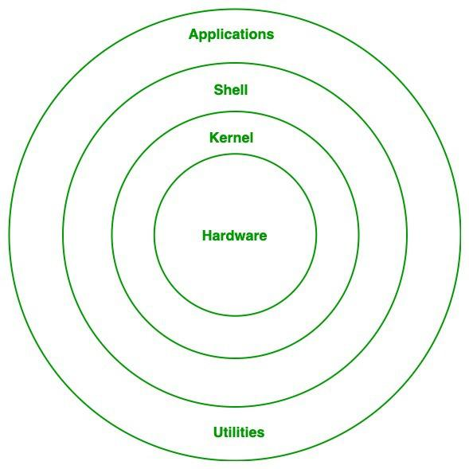
- WHAT IS LINUX?

Linux is an open-source operating system with high security based on the Unix architecture. Linux is multiuser based OS. The core part of Linux is called the kernel, which manages hardware resources and communication between software and hardware. Linux can be freely modified, distributed, and used by anyone.
Linux Architecture
- FEATURES OF LINUX

- Open-source and free to use
- Multi-user capability
- Multitasking support
- High security
- Stable and reliable performance
- Portable across hardware platforms
- Strong networking support

- APPLICATIONS OF LINUX

- No licensing cost
- High level of security
- Efficient performance on low-end hardware
- Large community support
- Customizable and flexible
- Less prone to viruses and malware

- LINUX OS DISTRIBUTIONS

Many of the users taken the linux OS and modified according to their requirements and released into the market with different names called Linux distribution.
RedHat, Ubuntu, Debian, Centos, Fedora, Opensuse, Kali Linux, Amazon Linux and Rocky Linux

- LINUX COMMANDS

In Linux we have different types of commands

- SYSTEM COMMANDS

System commands are used to get information about the system and to manage system-level operations such as processes, memory, and system status.

uname – Displays system information
uptime – Shows how long the system has been running
top – Displays running processes
ps – Shows active processes
shutdown – Shuts down the system

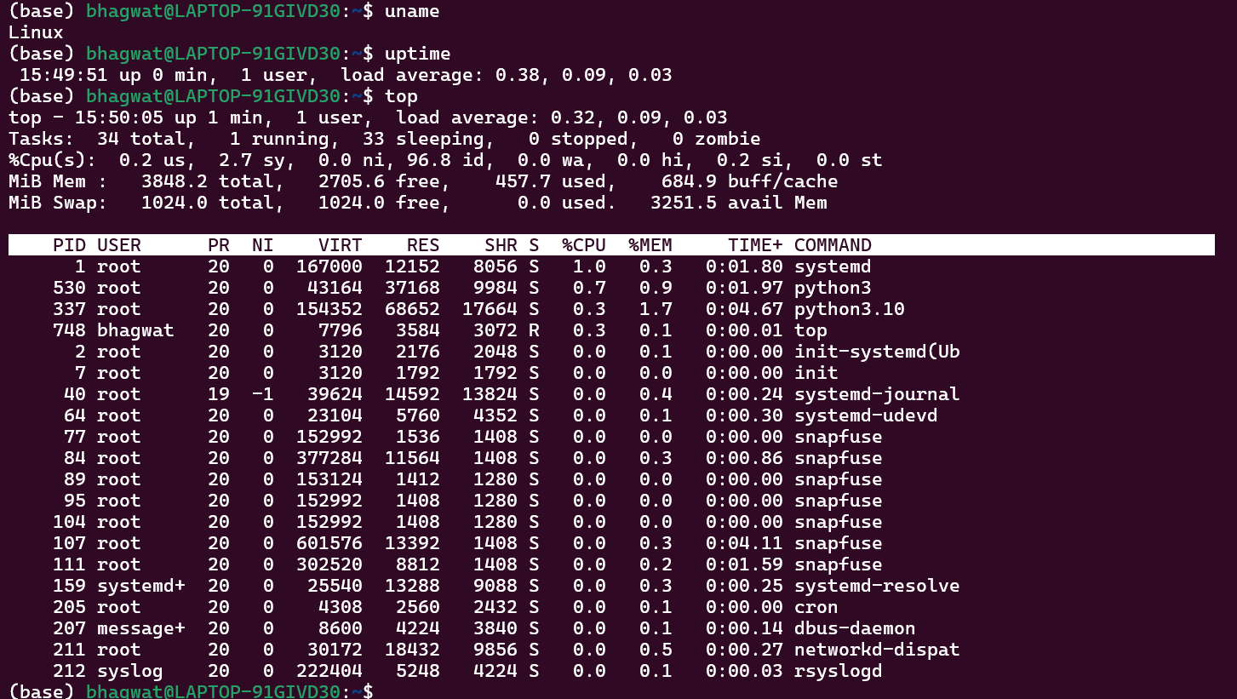

- HARDWARE COMMANDS

Hardware commands provide information about the system hardware such as CPU, memory, disks, and connected devices.

lsblk – Lists block devices
lscpu – Displays CPU information
free – Shows memory usage
df – Displays disk space usage
hwinfo – Shows detailed hardware information

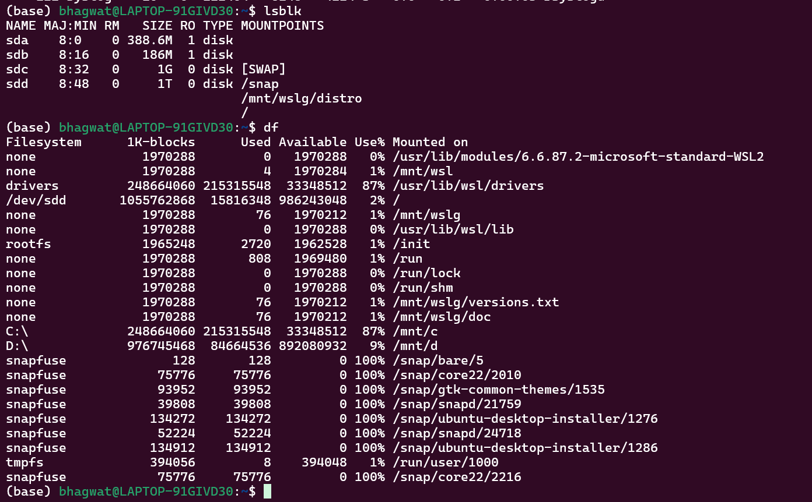

- FILE COMMANDS

File commands are used to create, view, modify, copy, move, and delete files and directories.

ls – Lists files and directories
cp – Copies files
mv – Moves or renames files
rm – Deletes files
mkdir – Creates directories
cat – Displays file content

- PERMISSION COMMANDS

Permission commands are used to control access rights of files and directories. Linux uses read, write, and execute permissions.

chmod – Changes file permissions
chown – Changes file ownership
chgrp – Changes group ownership
ls -l – Displays permission details

- USER COMMANDS

User commands are used to manage users and groups in the Linux system.

whoami – Displays current user
who – Shows logged-in users
adduser – Adds a new user
passwd – Changes user password
su – Switches user
logout – Logs out the user

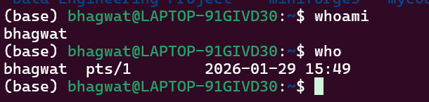

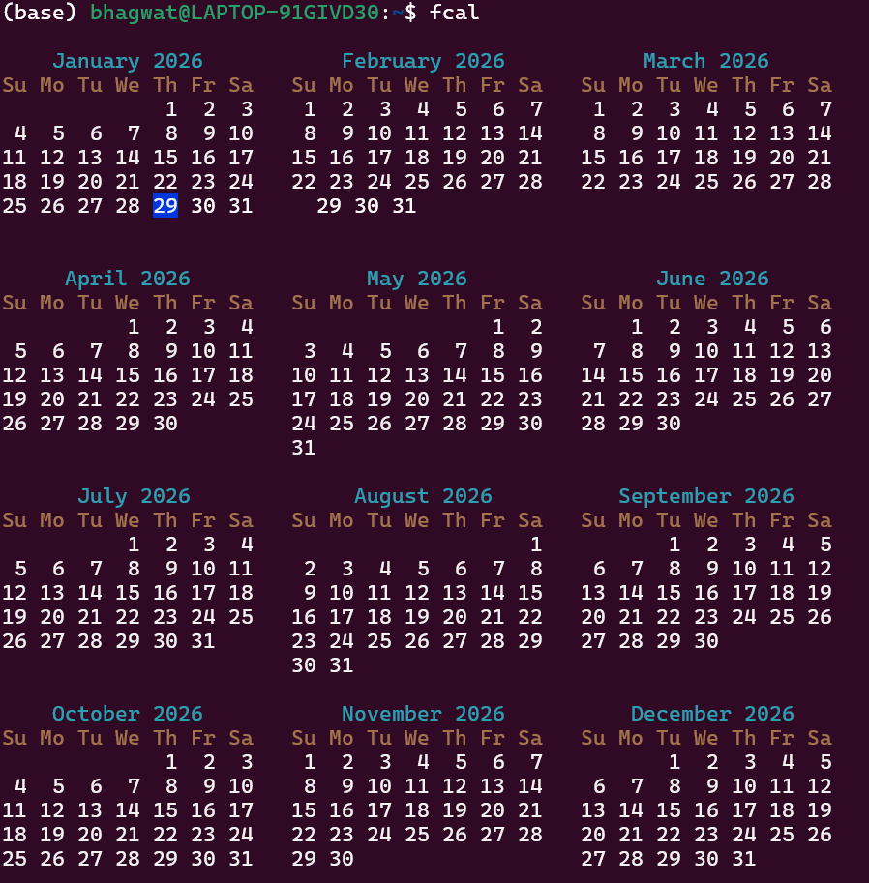

- SEARCH COMMANDS

Search commands are used to search for files, directories, or text inside files.

find – Searches for files and directories
locate – Quickly finds file locations
grep – Searches text patterns in files
which – Finds command location

- NETWORKING COMMANDS

Networking commands are used to configure, monitor, and troubleshoot network connections.

ifconfig – Displays network interface details
ip – Shows IP address information
ping – Checks network connectivity
netstat – Displays network statistics
ssh – Connects to remote systems securely
wget – Downloads files from the internet

